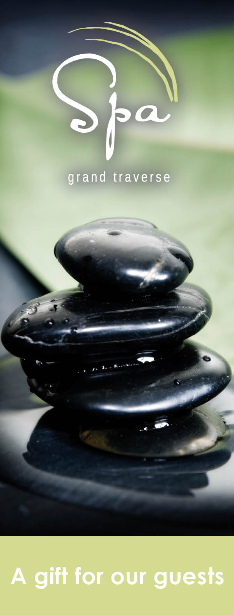
welcome
MI Association of Health Plans

July 25-August 2, 2021

SPA Grand Traverse Special Offer

10% off spa treatments

• Excludes salon, waxing and eyelash services. Not valid with other offers. Certain restrictions
may apply. Reservations required.

Reservations:
800-748-0303, ext. 6750
spadesk@gtresort.com

For a complete Spa menu visit:
www.grandtraverseresort.com

Spa Hours:
Sunday-Monday 8am-4pm
Tuesday-Wednesday 9am-6pm
Thursday-Friday 9am-8pm
Saturday 9am-6pm

